Elements for congregation
(for copying and pasting into order of service!)

Hymn 1

1.
Creator of the stars of night,
Your people’s everlasting light,
O Christ, redeemer of us all,
We pray you hear us when we call.

2.
In sorrow that the ancient curse
Should doom to death a universe,
You came, O saviour, to set free
Your own, in glorious liberty.

3.
When this old world drew on toward night,
You came, but not in splendour bright,
Not as a monarch, but the child
Of Mary, blameless mother mild.

4.
At your great name, O Jesus, now
All knees must bend, all hearts must bow;
All things on earth with one accord,
Like those in heaven, shall call you Lord.

5.
Come in your holy might, we pray;
Redeem us for eternal day,
Defend us while we dwell below
From all assaults of our dread foe.

6.
To God creator, God the son,
And God the spirit, three in one,
Praise, honour, might and glory be
From age to age eternally. Amen.

Antiphons
For each Antiphon, the choir sings the verse in Latin, then all repeat in English.
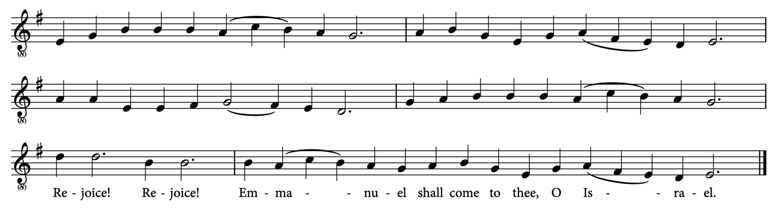

1.
O come, thou Wisdom from on high,
And order all things far and nigh.
To us the path of knowledge show,
And cause us in her ways to go.
Rejoice! Rejoice! Emmanuel shall come to thee, O Israel.

2.
O come, O come, thou Lord of might,
Who to thy tribes on Sinai’s height
In ancient times didst give the law
In cloud and majesty and awe.
Rejoice! Rejoice! Emmanuel shall come to thee, O Israel.

3.
O come, thou Rod of Jesse, free
Thine own from Satan’s tyranny.
From depths of hell thy people save,
And give them victory o’er the grave.
Rejoice! Rejoice! Emmanuel shall come to thee, O Israel.

4.
O come, thou Key of David, come,
And open wide our heavenly home.
Make safe the way that leads on high,
And close the path to misery.
Rejoice! Rejoice! Emmanuel shall come to thee, O Israel.

5.
O come, thou Dayspring, come and cheer
Our spirits by thine advent here.
Disperse the gloomy clouds of night,
And death’s dark shadows put to flight.
Rejoice! Rejoice! Emmanuel shall come to thee, O Israel.

6.
O come, thou king of nations, bind
In one the hearts of all mankind.
Bid thou our sad divisions cease,
And be thyself our king of peace.
Rejoice! Rejoice! Emmanuel shall come to thee, O Israel.

Before and after the 7th reading:
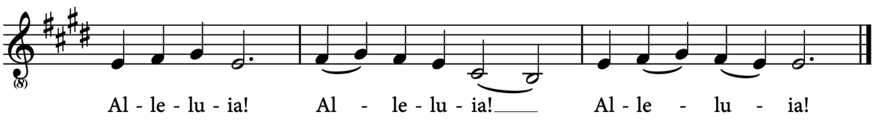
7.
O come, O come, Emmanuel,
And ransom captive Israel,
That mourns in lonely exile here,
Until the Son of God appear.
Rejoice! Rejoice! Emmanuel shall come to thee, O Israel.

Hymn 2
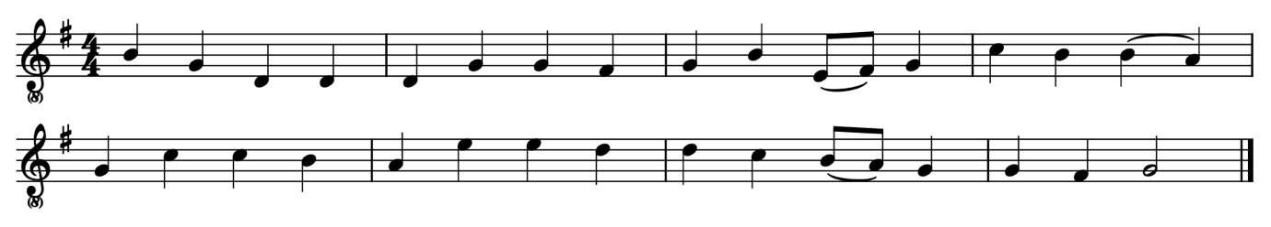
1.
Come, thou long-expected Jesus,
Born to set thy people free;
From our fears and sins release us,
Let us find our rest in thee.

2.
Israel’s strength and contemplation,
Hope of all the earth thou art,
Dear desire of every nation,
Joy of every longing heart.

3.
Born thy people to deliver,
Born a child and yet a king,
Born to reign in us for ever,
Now thy gracious kingdom bring.

4.
By thine own eternal spirit,
Rule in all our hearts alone;
By thine all-sufficient merit
Raise us to thy glorious throne.

Nunc dimittis
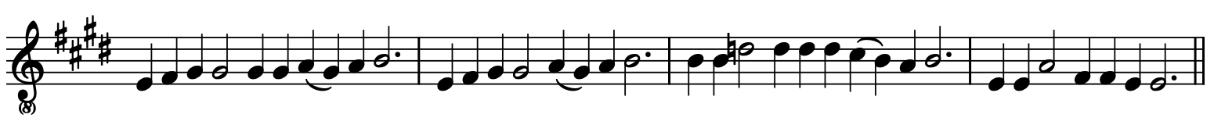
Protect us, Lord, as we stay awake;
Watch over us as we sleep;
That awake, we may keep watch with Christ,
And asleep, rest in his peace.
(The choir sings a short psalm, ending “…and will be for ever. Amen”, after which everyone repeats “Protect us, Lord…”.)

Alma redemptoris mater
The choir sings:
Alma Redemptoris Mater, quae pervia caeli porta manes, et stella maris,
succurre cadenti surgere qui curat populo:
Tu quae genuisti, natura mirante, tuum sanctum Genitorem:
Virgo prius ac posterius, Gabrielis ab ore sumens illud Ave, peccatorum miserere.

(Loving Mother of the Redeemer, the gate by which mortals enter heaven, and star of the sea,
help your fallen people who seek to rise:
You who gave birth, amazing nature, to your sacred Creator:
Virgin before and after, taking the ‘Ave’ from the mouth of Gabriel,
have mercy on our sins.)

Hymn 3
1.
On Jordan’s bank the Baptist’s cry
Announces that the Lord is nigh;
Awake and hearken, for he brings
Glad tidings from the king of kings.

2.
Then cleansed be every breast from sin;
Make straight the way for God within;
Prepare we in our hearts a home,
Where such a mighty guest might come.

3.
For thou art our salvation, Lord,
Our refuge and our great reward;
Without thy grace, we waste away,
Like flow’rs that wither and decay.

4.
To heal the sick, stretch out thy hand,
And bid the fallen sinner stand;
Shine forth and let thy light restore
Earth’s own true loveliness once more.

5.
All praise, eternal Son, to thee,
Whose advent sets thy people free;
Whom with the Father we adore,
And Holy Ghost for ever more.

